MODULE-6 : VPC

Sub-task 1 – Configure VPC

1. The VPC should have a name following this convention <ProjectName>-Network and a CIDR block of 10.0.0.0/16.

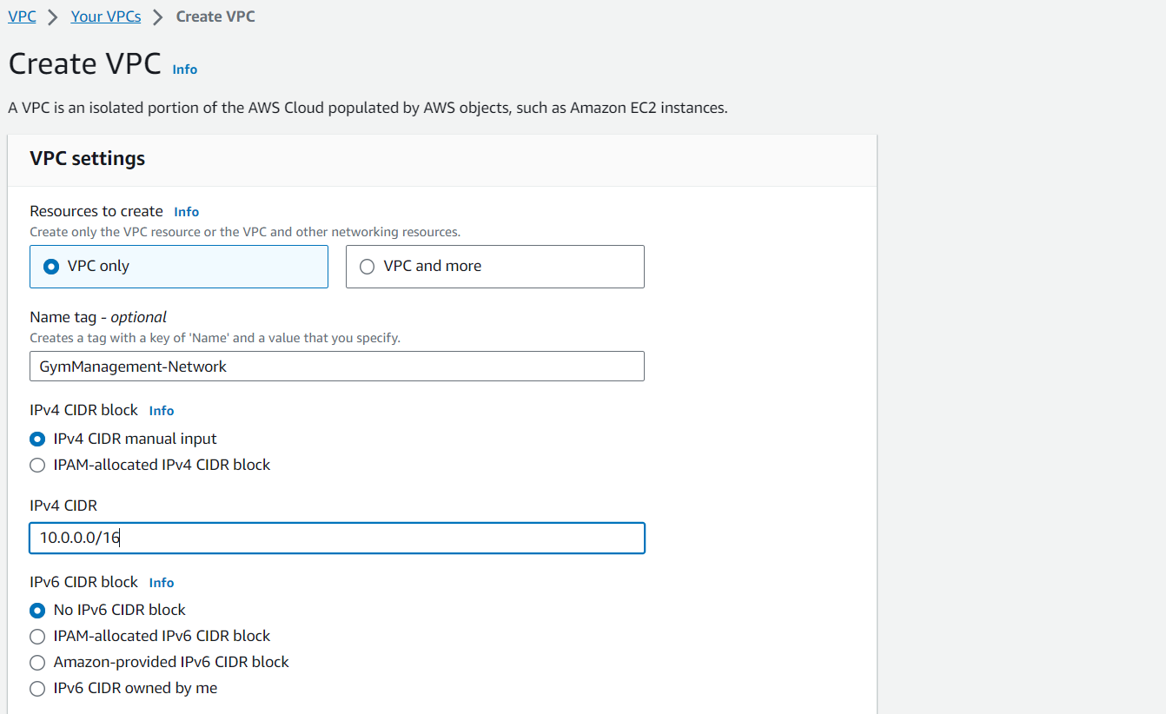

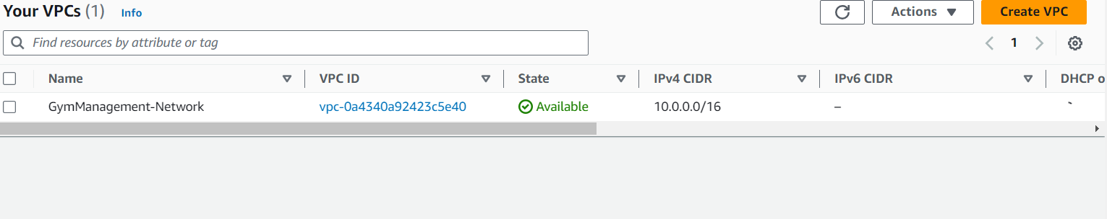

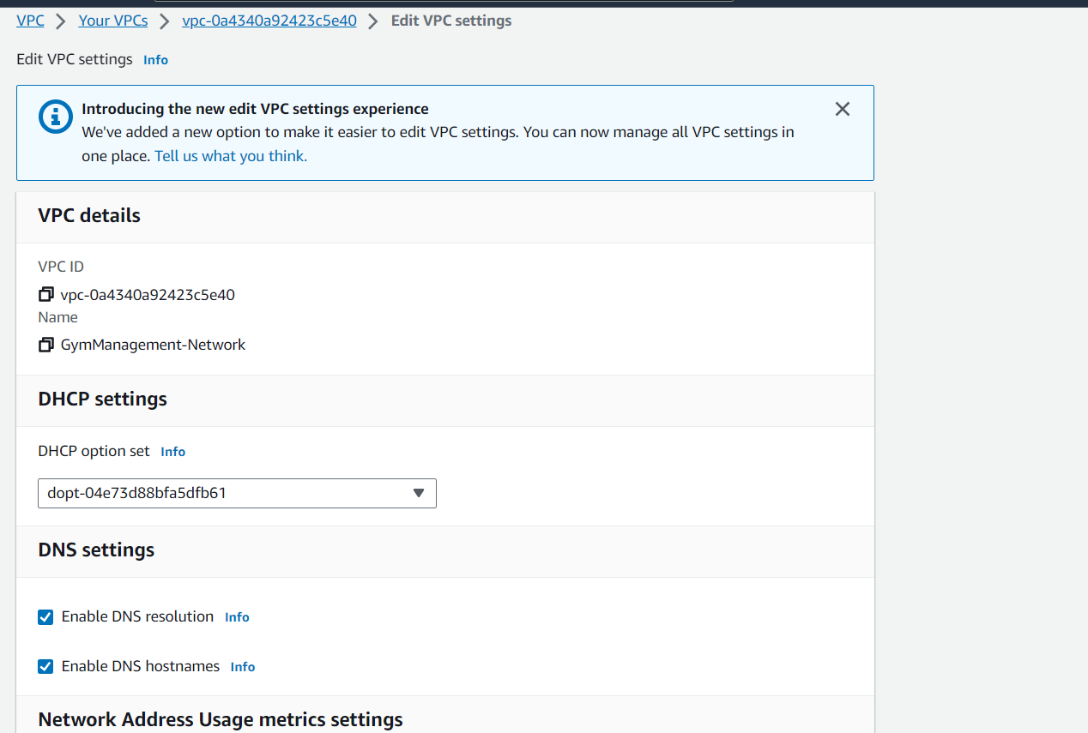

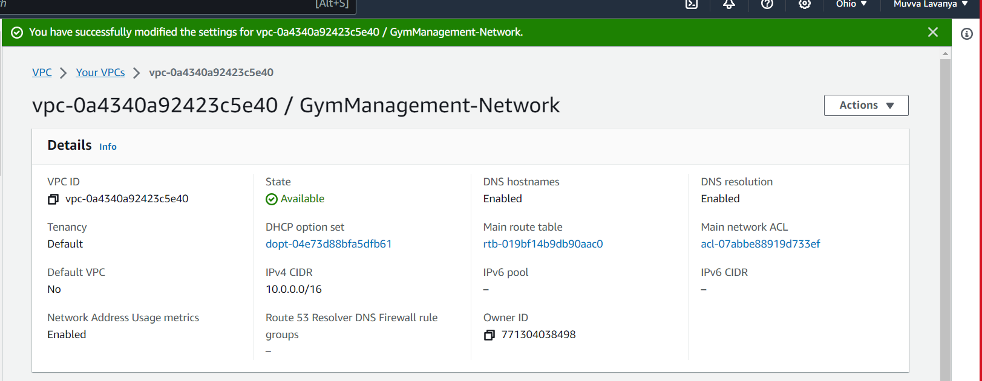

2.Create an internet gateway named <ProjectName>-IGW and attach it to the VPC.

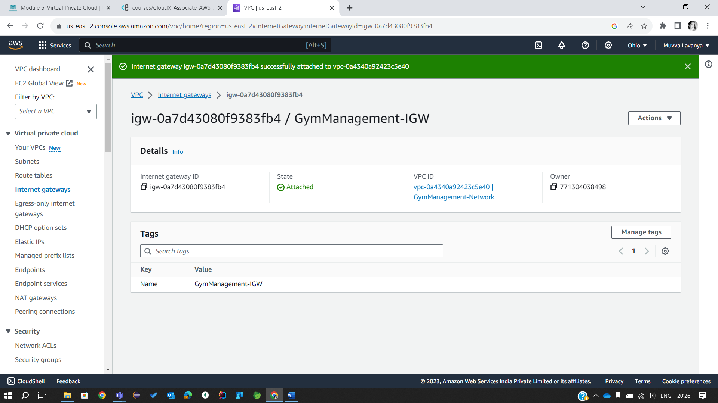

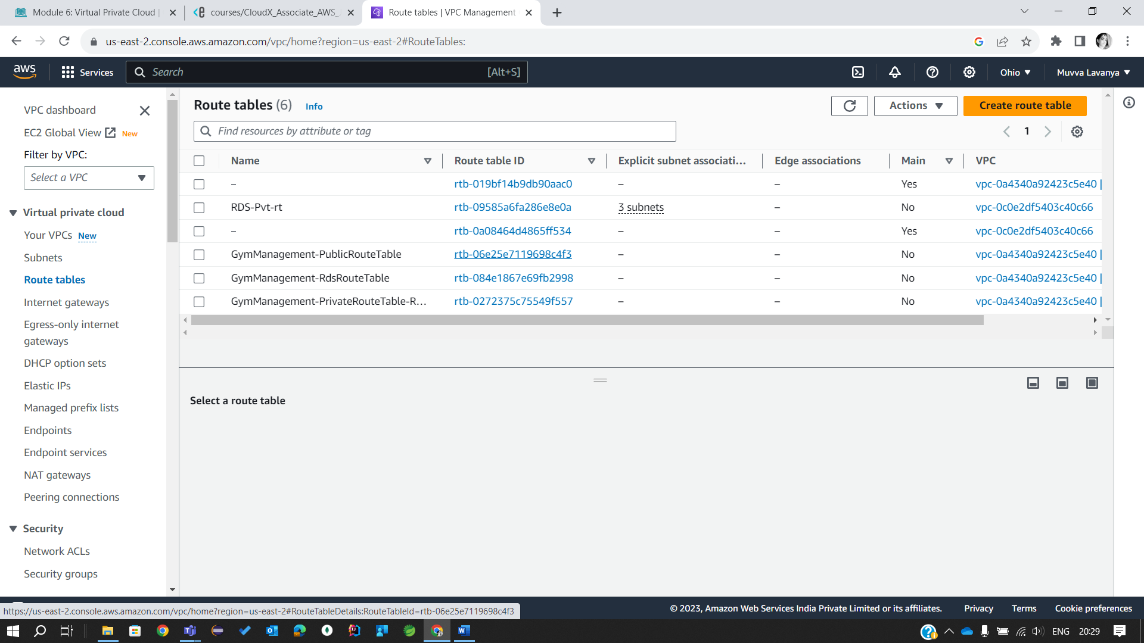

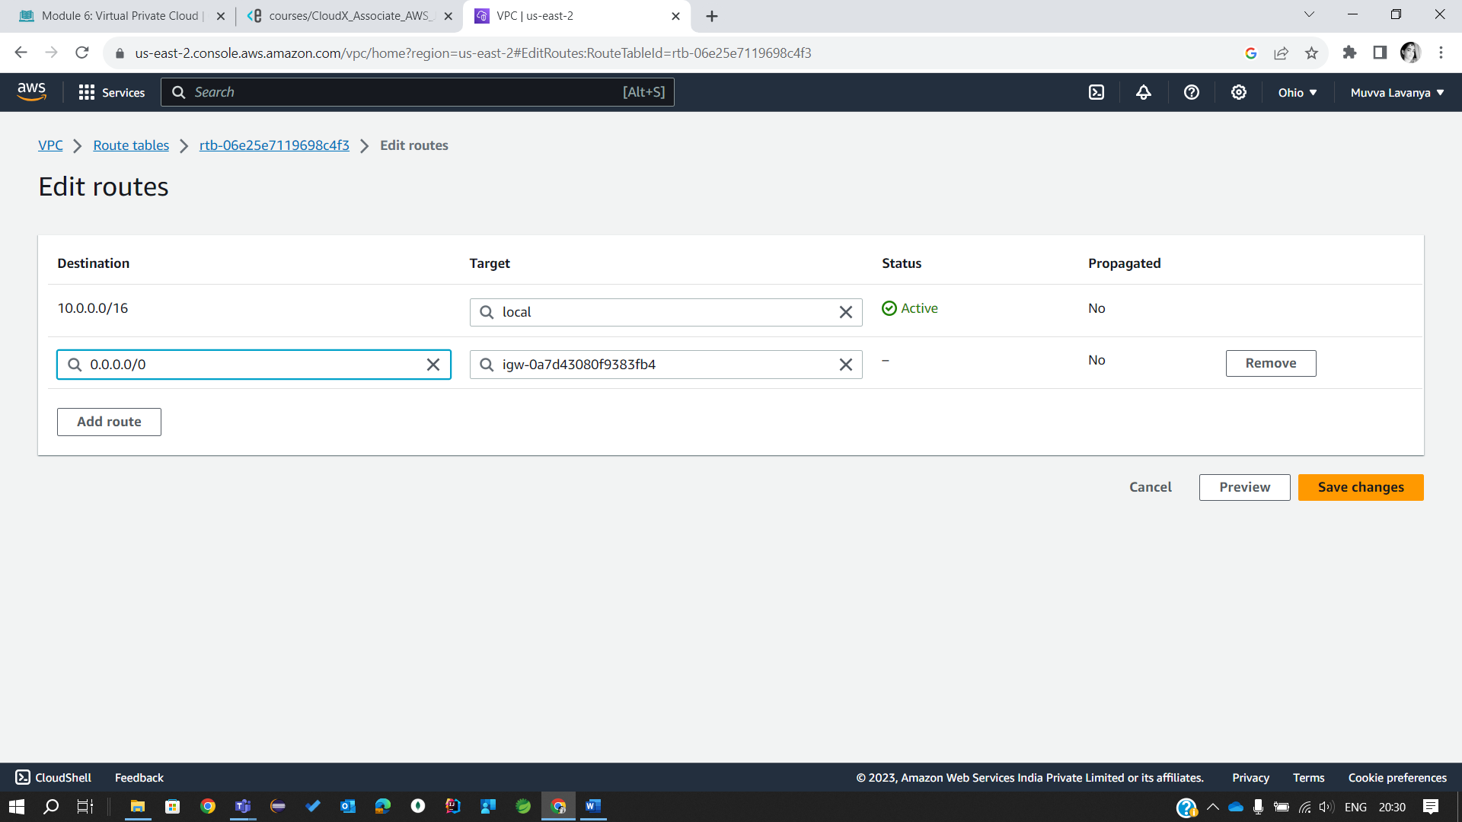

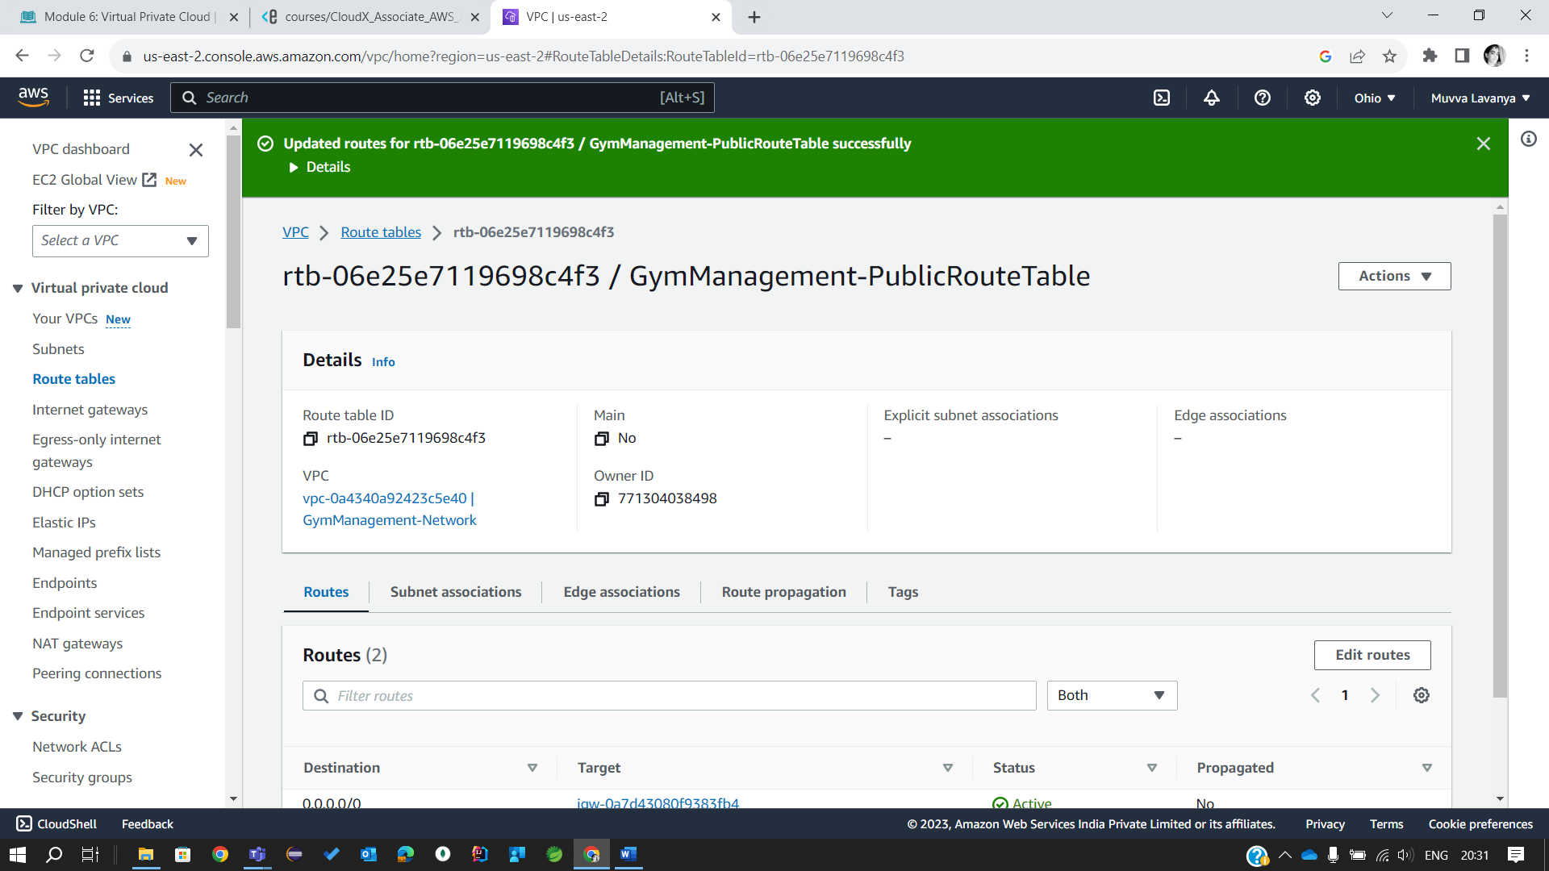

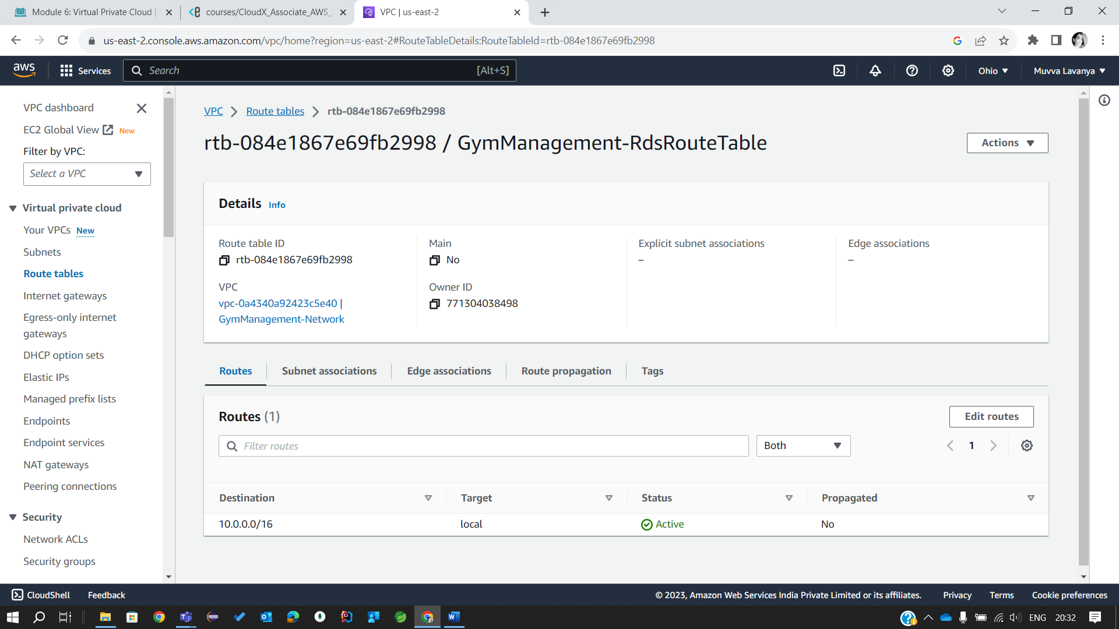

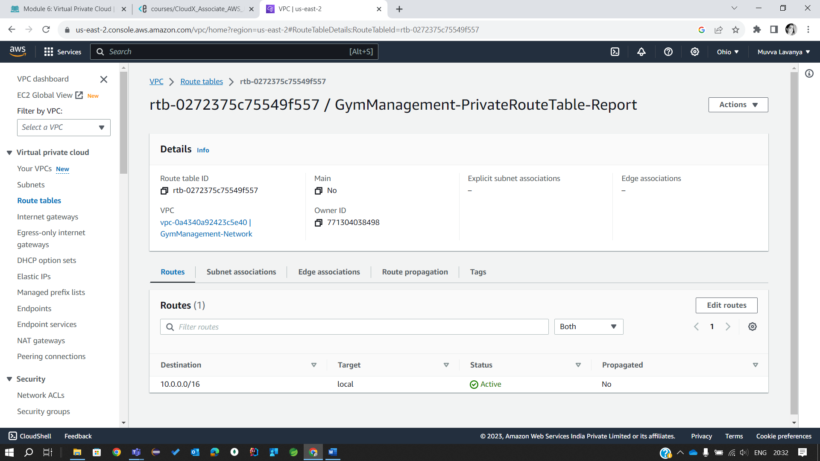

3. Create public subnet in the first AZ of the VPC:

* *<ProjectName>-PublicSubnet-Main* with a CIDR block of *10.0.11.0/24*.
* Make it public and choose *Auto-Assign Public IP*.
* Create a new route table named *<ProjectName>-PublicRouteTable*. Add a *10.0.0.0/16* – *Local* route and a route to the *<ProjectName> IGW* to it.
* **Add a 0.0.0.0/0 - IGW route. This route is necessary and provides connection to the internet for subnets that are associated with the Route Table.**
* Associate the subnet with the new route table.

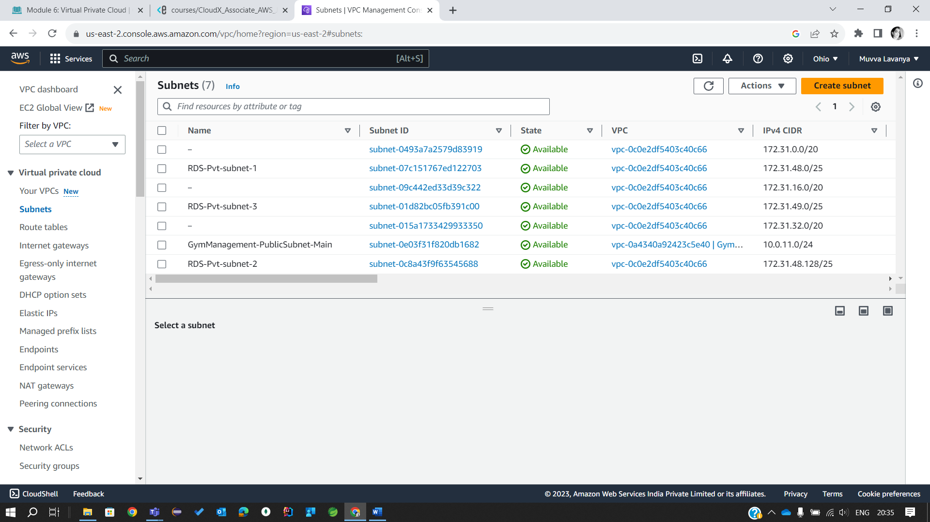

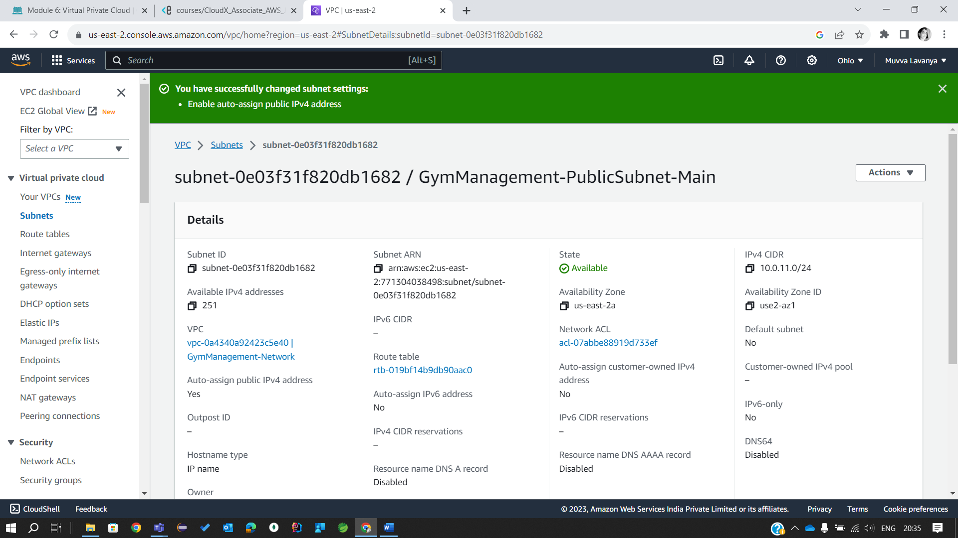

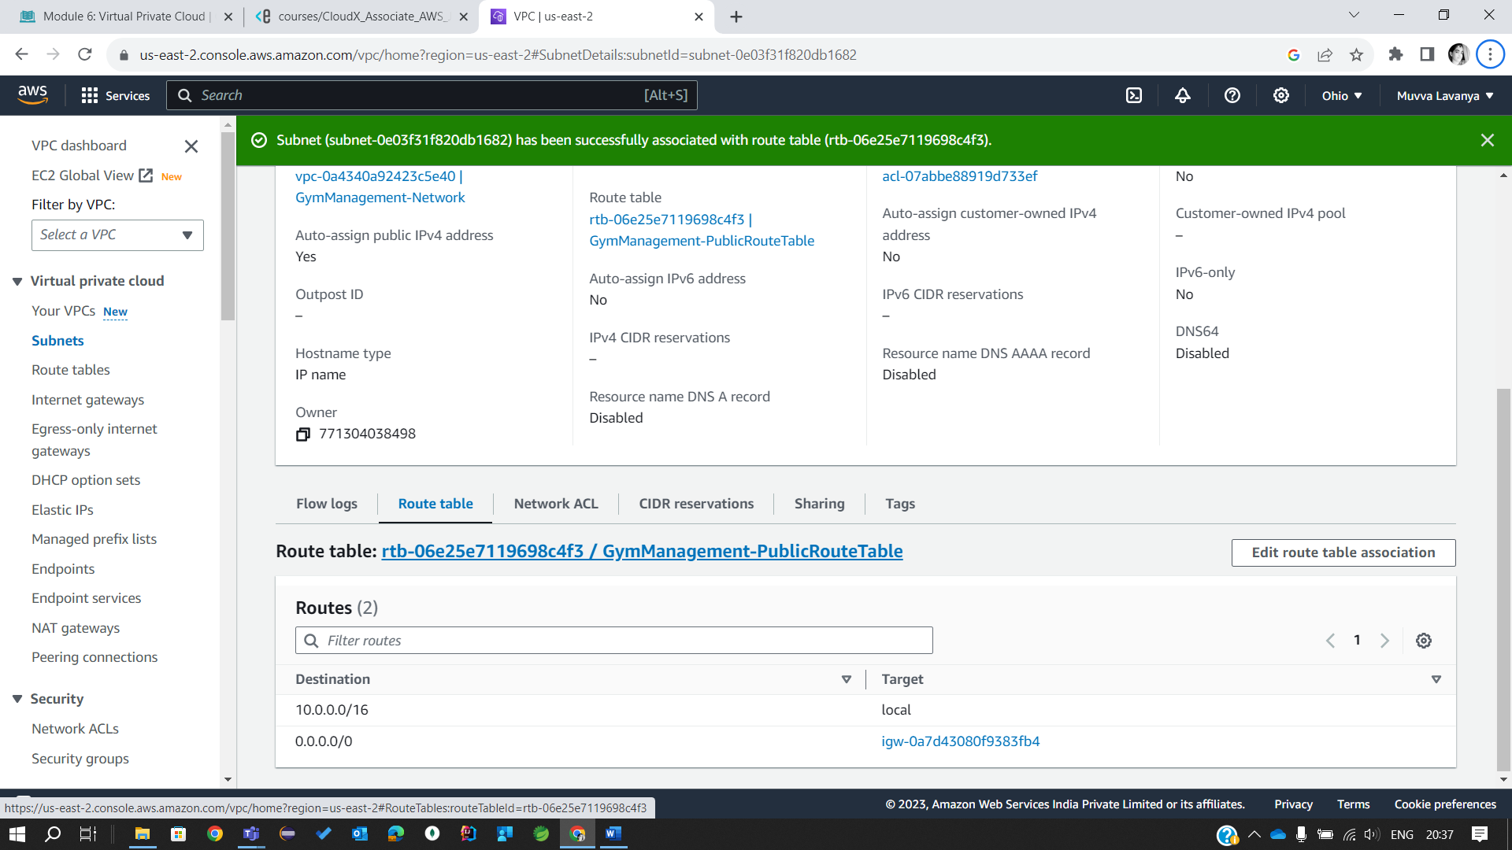

4. Create private subnet in the first AZ of the VPC for the Report microservice:

* *<ProjectName>-PrivateSubnet-Report* with a CIDR block of *10.0.12.0/24*.
* Create new route table named *<ProjectName>-PrivateRouteTable-Report*. Add a *10.0.0.0/16* – *Local* route to it.
* Associate private subnet with the new route table.

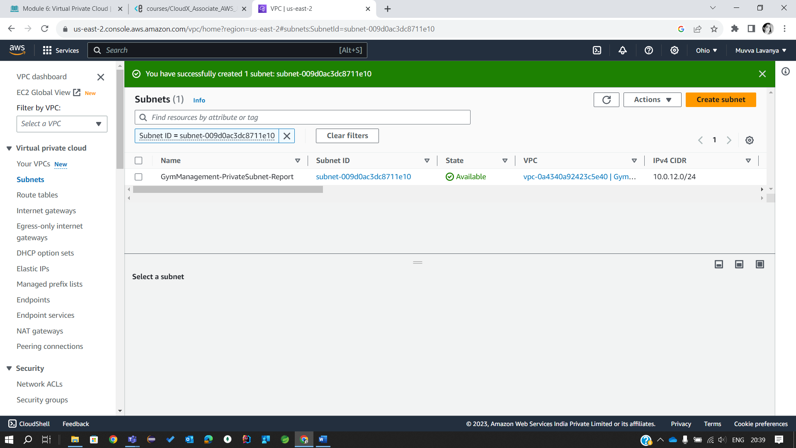

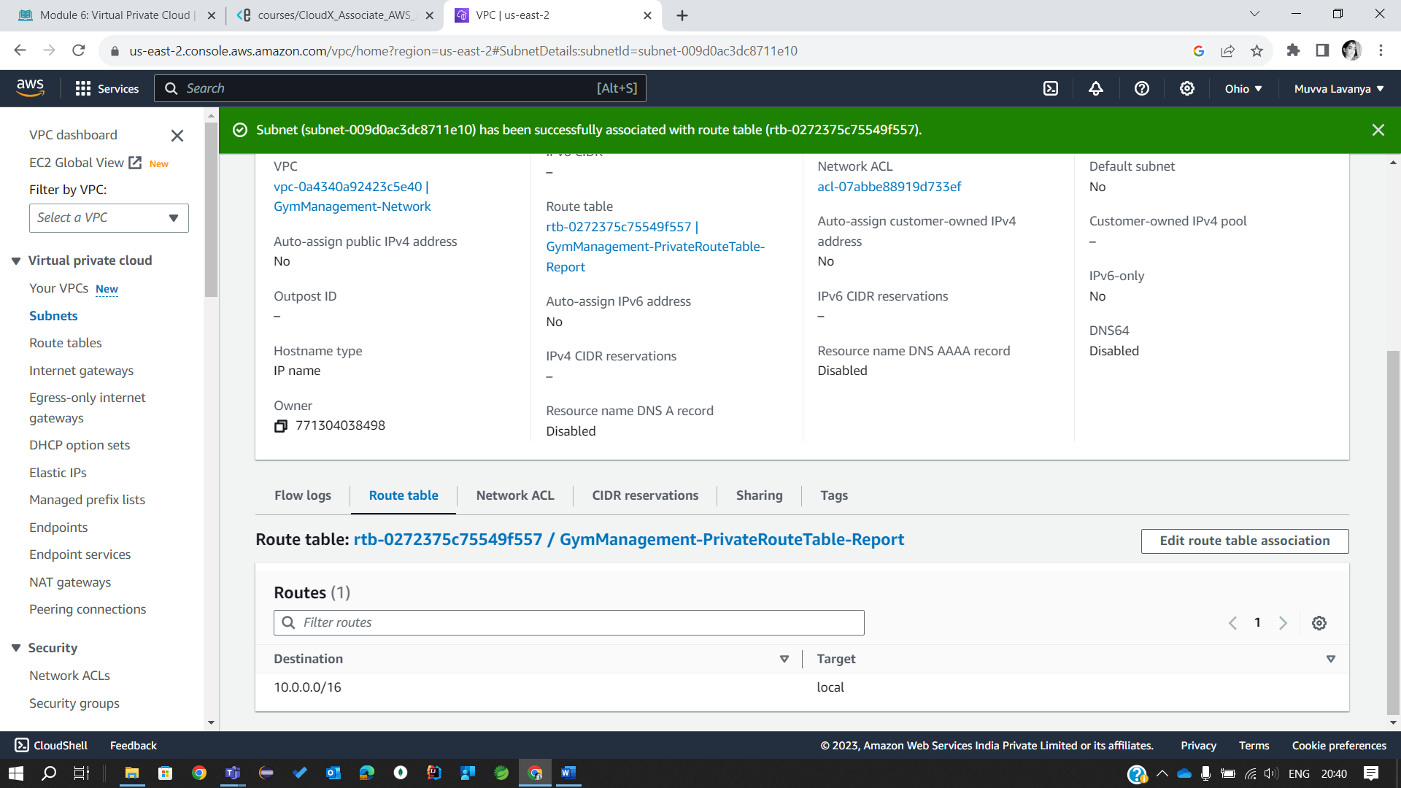

5. Create RDS subnet in the first AZ of the VPC:

* *<ProjectName>-DbSubnet-RDS* with a CIDR block of *10.0.13.0/24*.
* Create a new route table named *<ProjectName>-RdsRouteTable*. Add a *10.0.0.0/16* – *Local* route to it.
* Associate RDS subnet with the new route table.

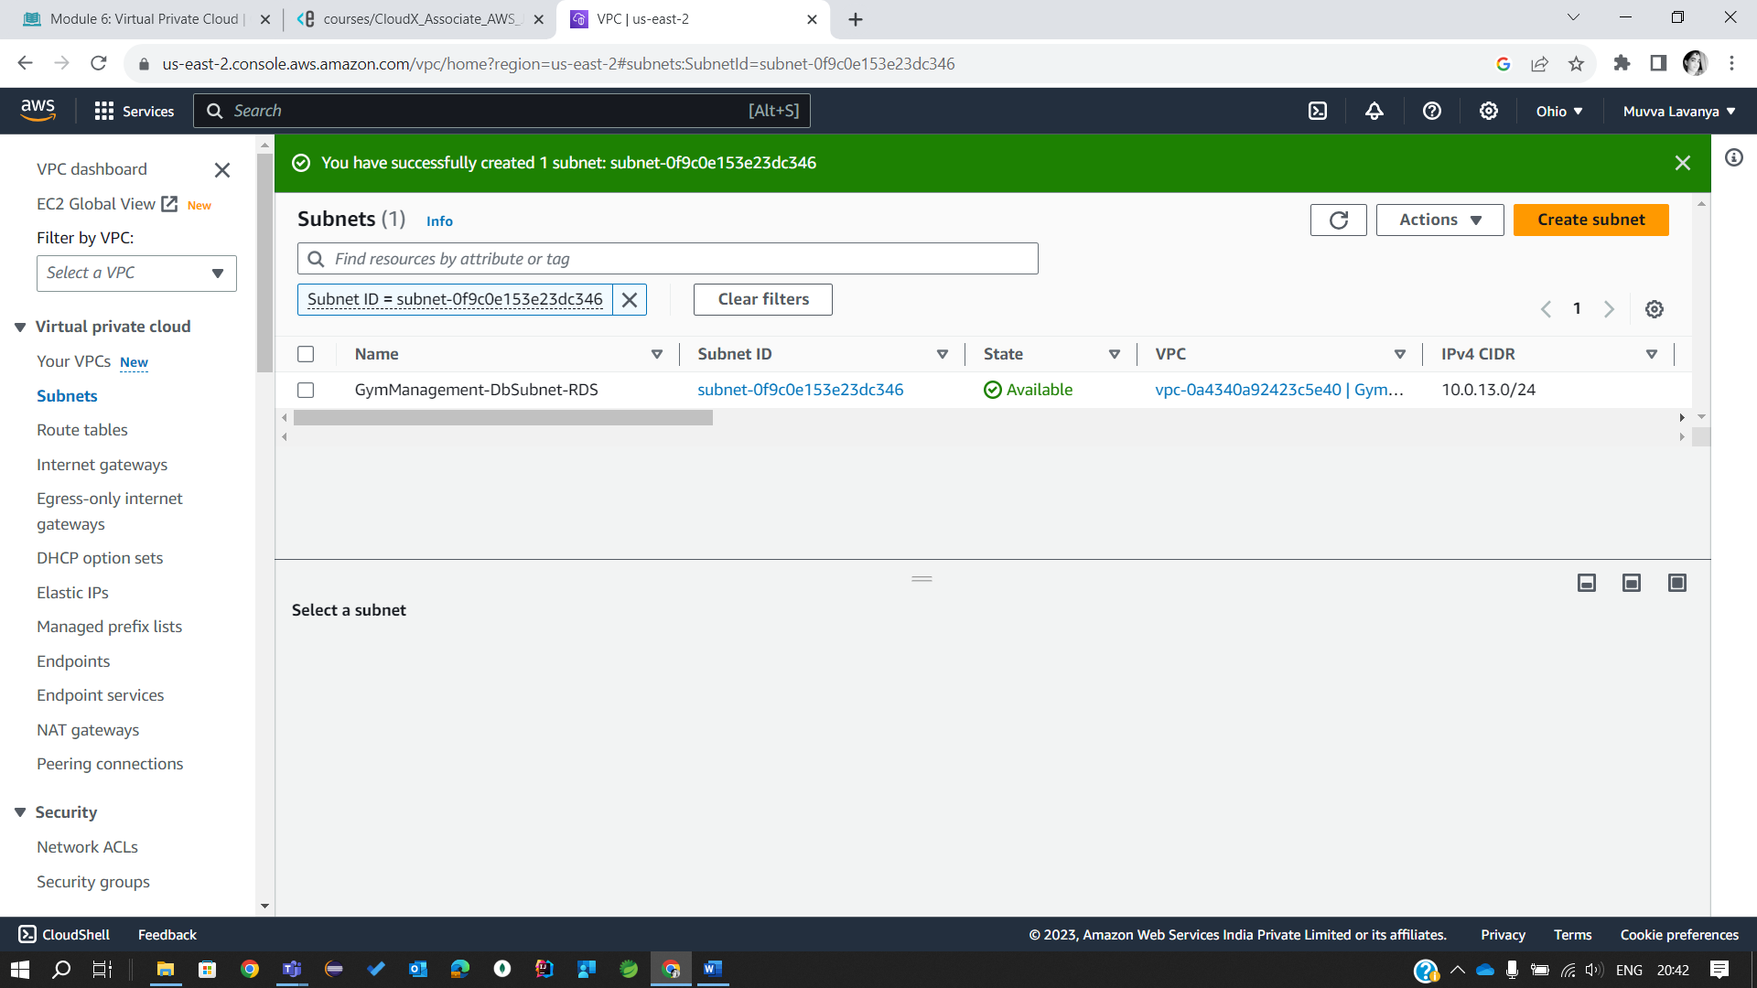

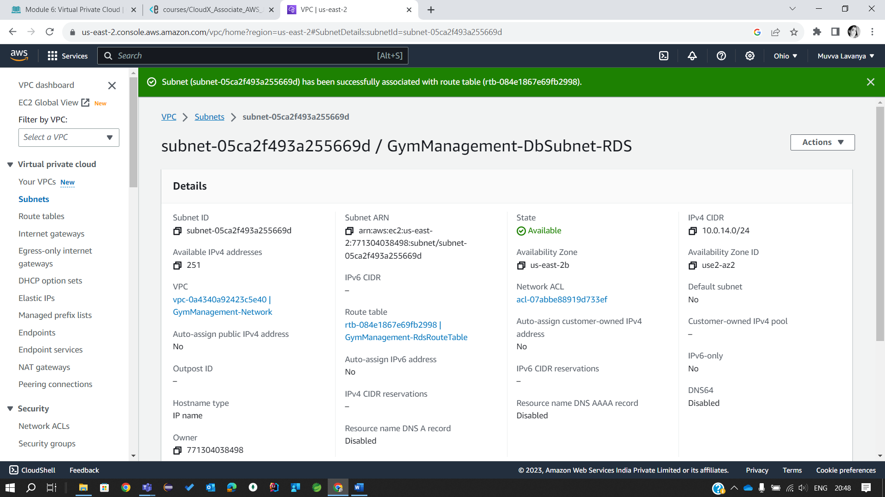

**Sub-task 2 – Connect to resources outside the VPC**

The instances like ***Main microservice*** and ***Reports microservice*** don't have access to the resources outside the VPC. In the future modules we will add some integrations with DynamoDB and SQS. Let's create VPC endpoints to provide connection between VPC and resources outside of it.

Create a VPC Endpoint for SQS:

* The name is -VPC-SQS-Endpoint.
* The type is Interface. Endpoints of this type are used to send traffic SQS.
* Choose the -Network VPC.
* Choose the *<ProjectName>-PrivateRouteTable-Main* and *<ProjectName>-PrivateRouteTable-Report* Route tables.

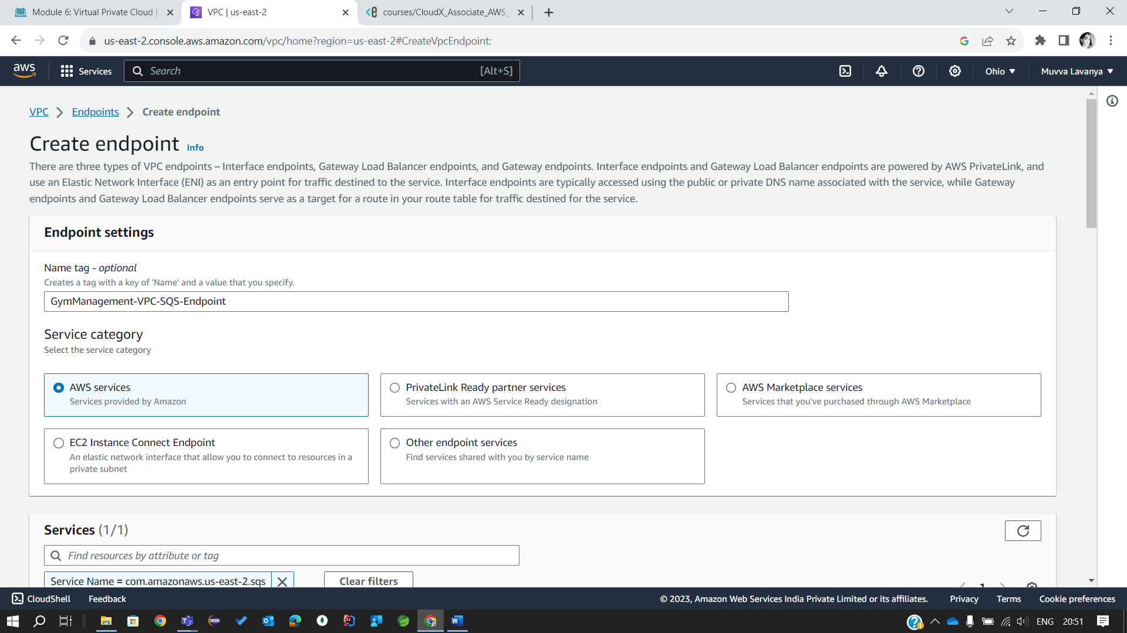

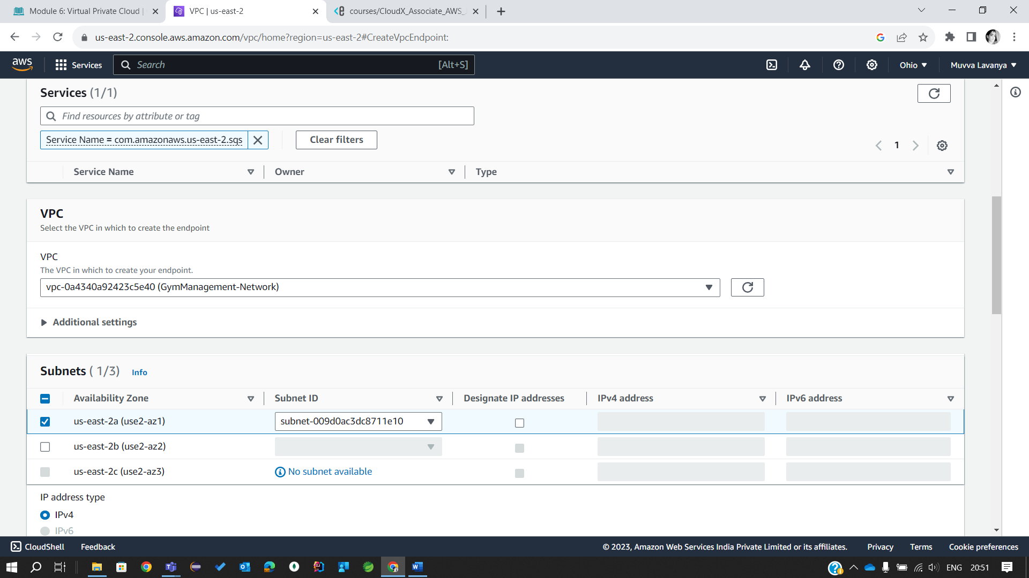

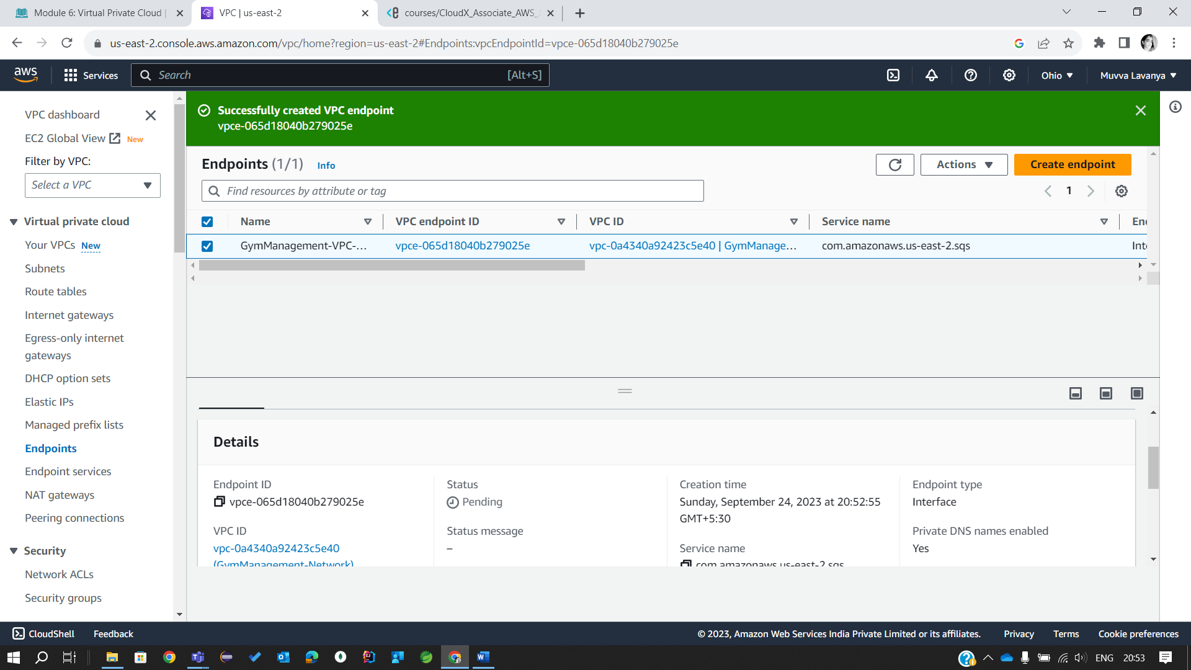

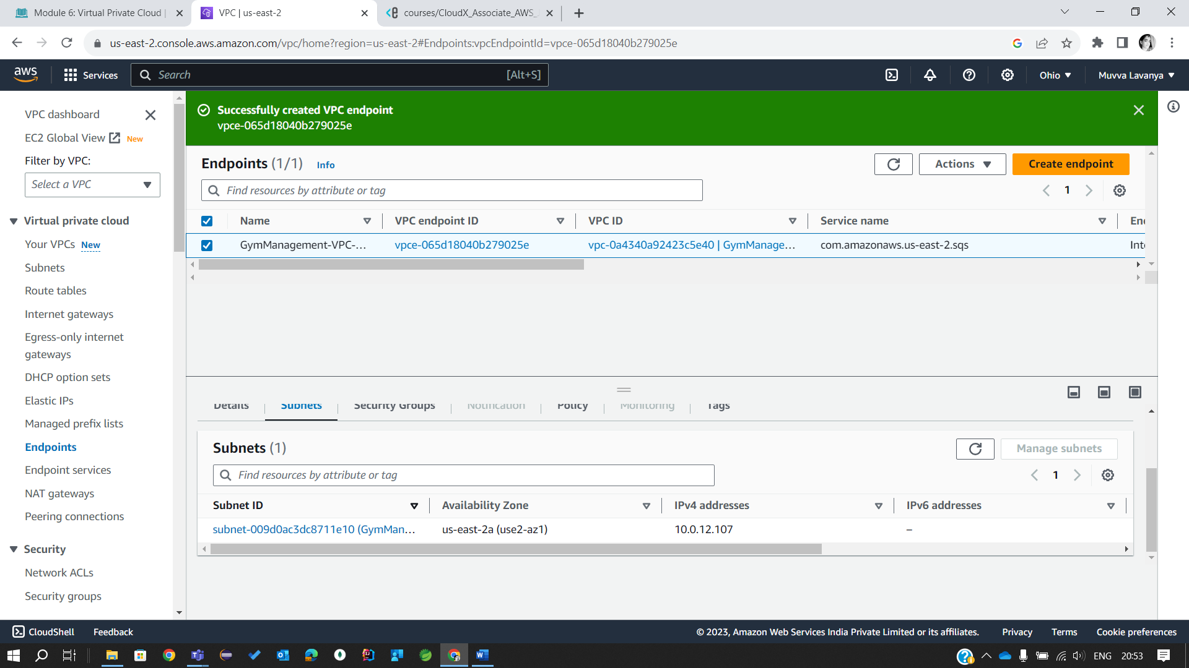

Create a VPC Endpoint for DynamoDB:

* The name is -VPC-DynamoDB-Endpoint.
* The type is Gateway. Endpoints of this type are used to send traffic S3 and DynamoDB.
* Choose the -Network VPC.
* Choose the *<ProjectName>-PrivateRouteTable-Report* Route table.

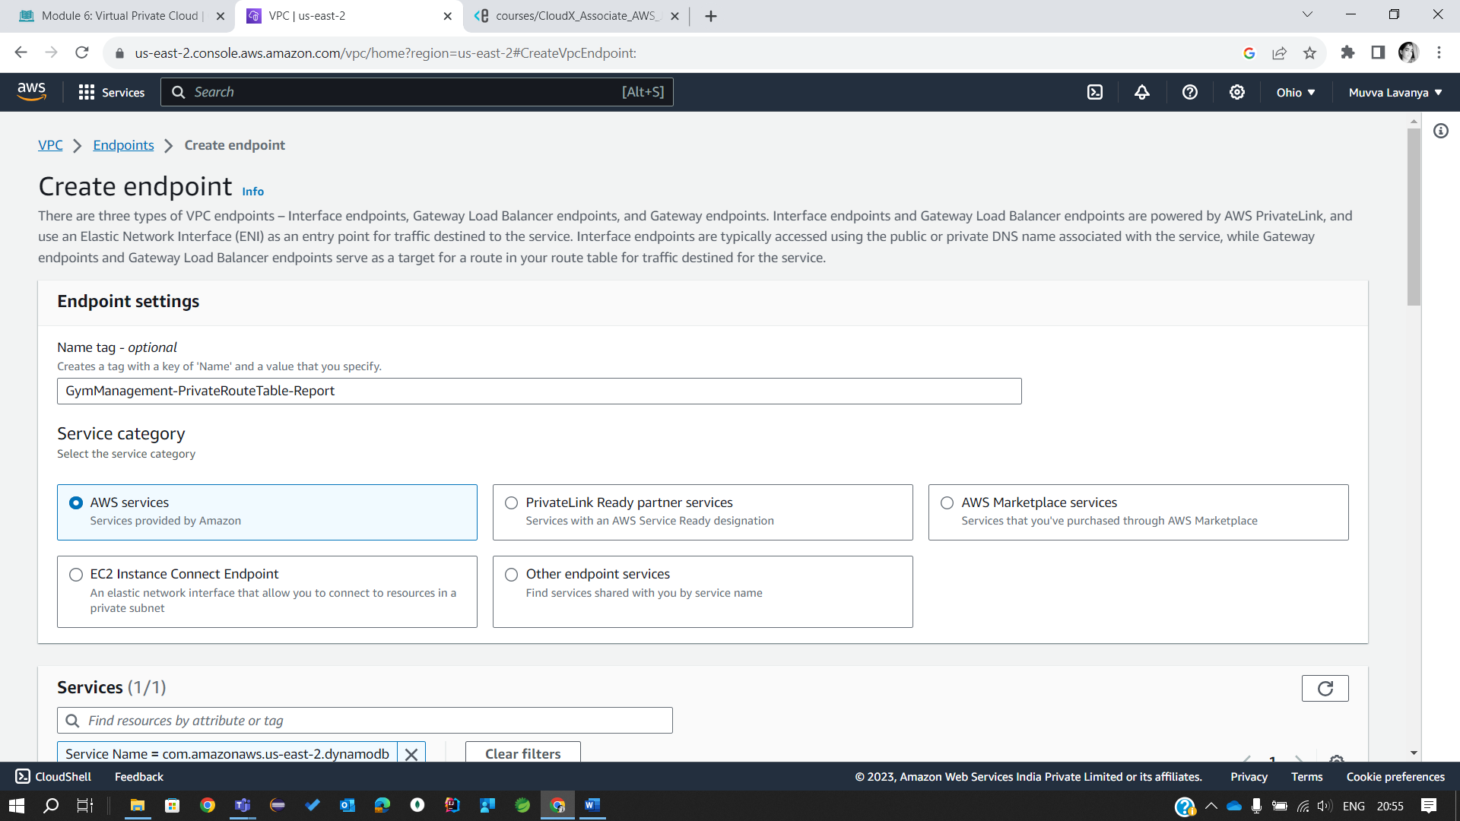

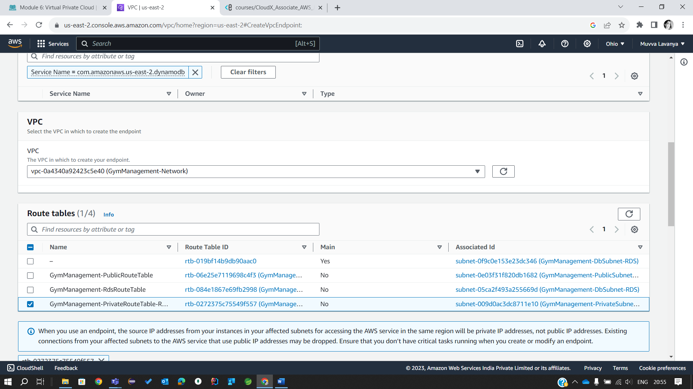

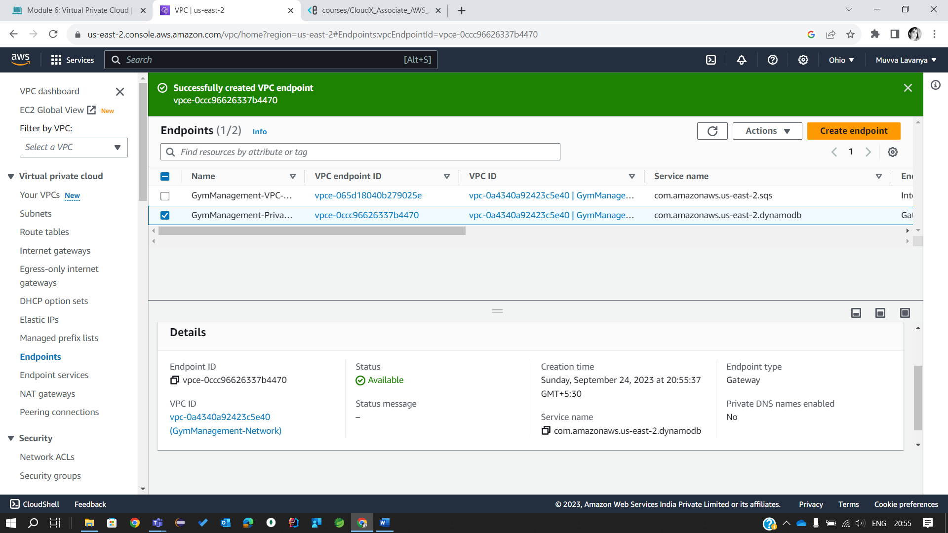

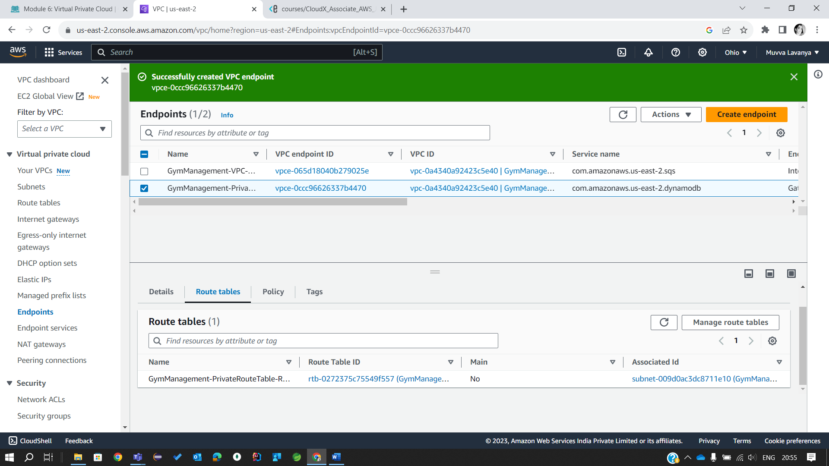

**Sub-task 3 – Create EC2 Instances in the VPC**

1. Create EC2 instance with the ***Main microservice*** from the previous EC2 Module in the private subnet - *<ProjectName>-PublicSubnet-Main*.

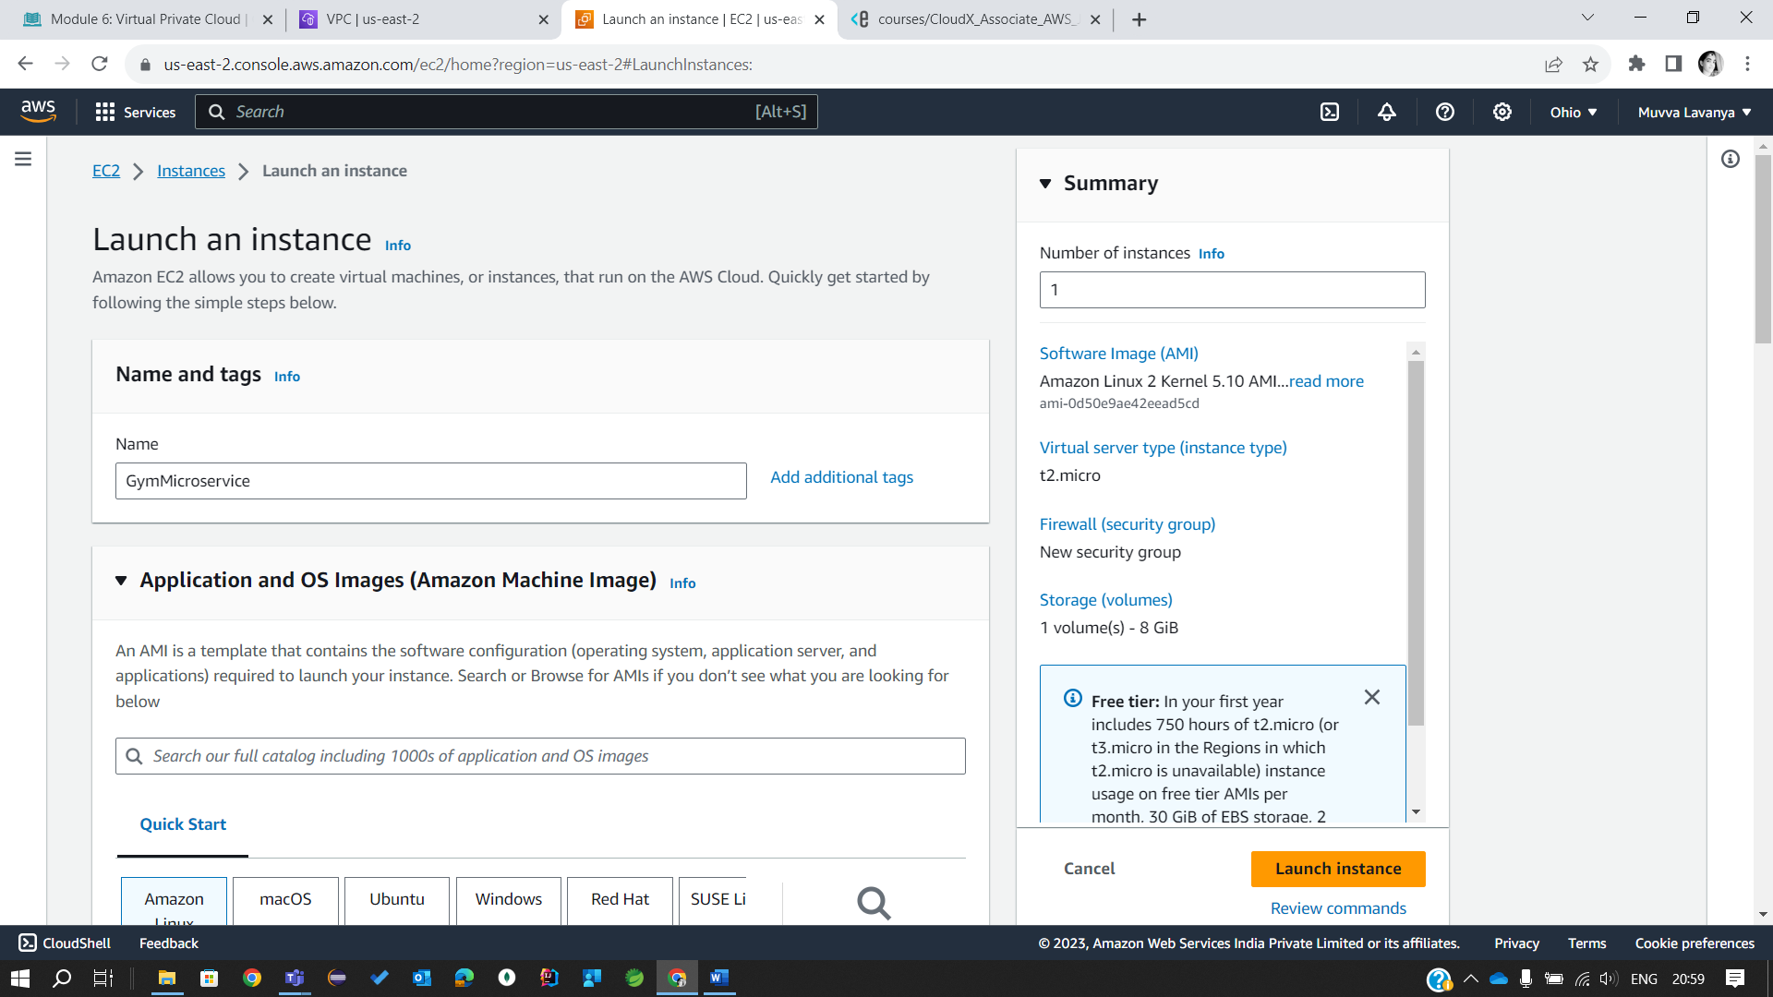

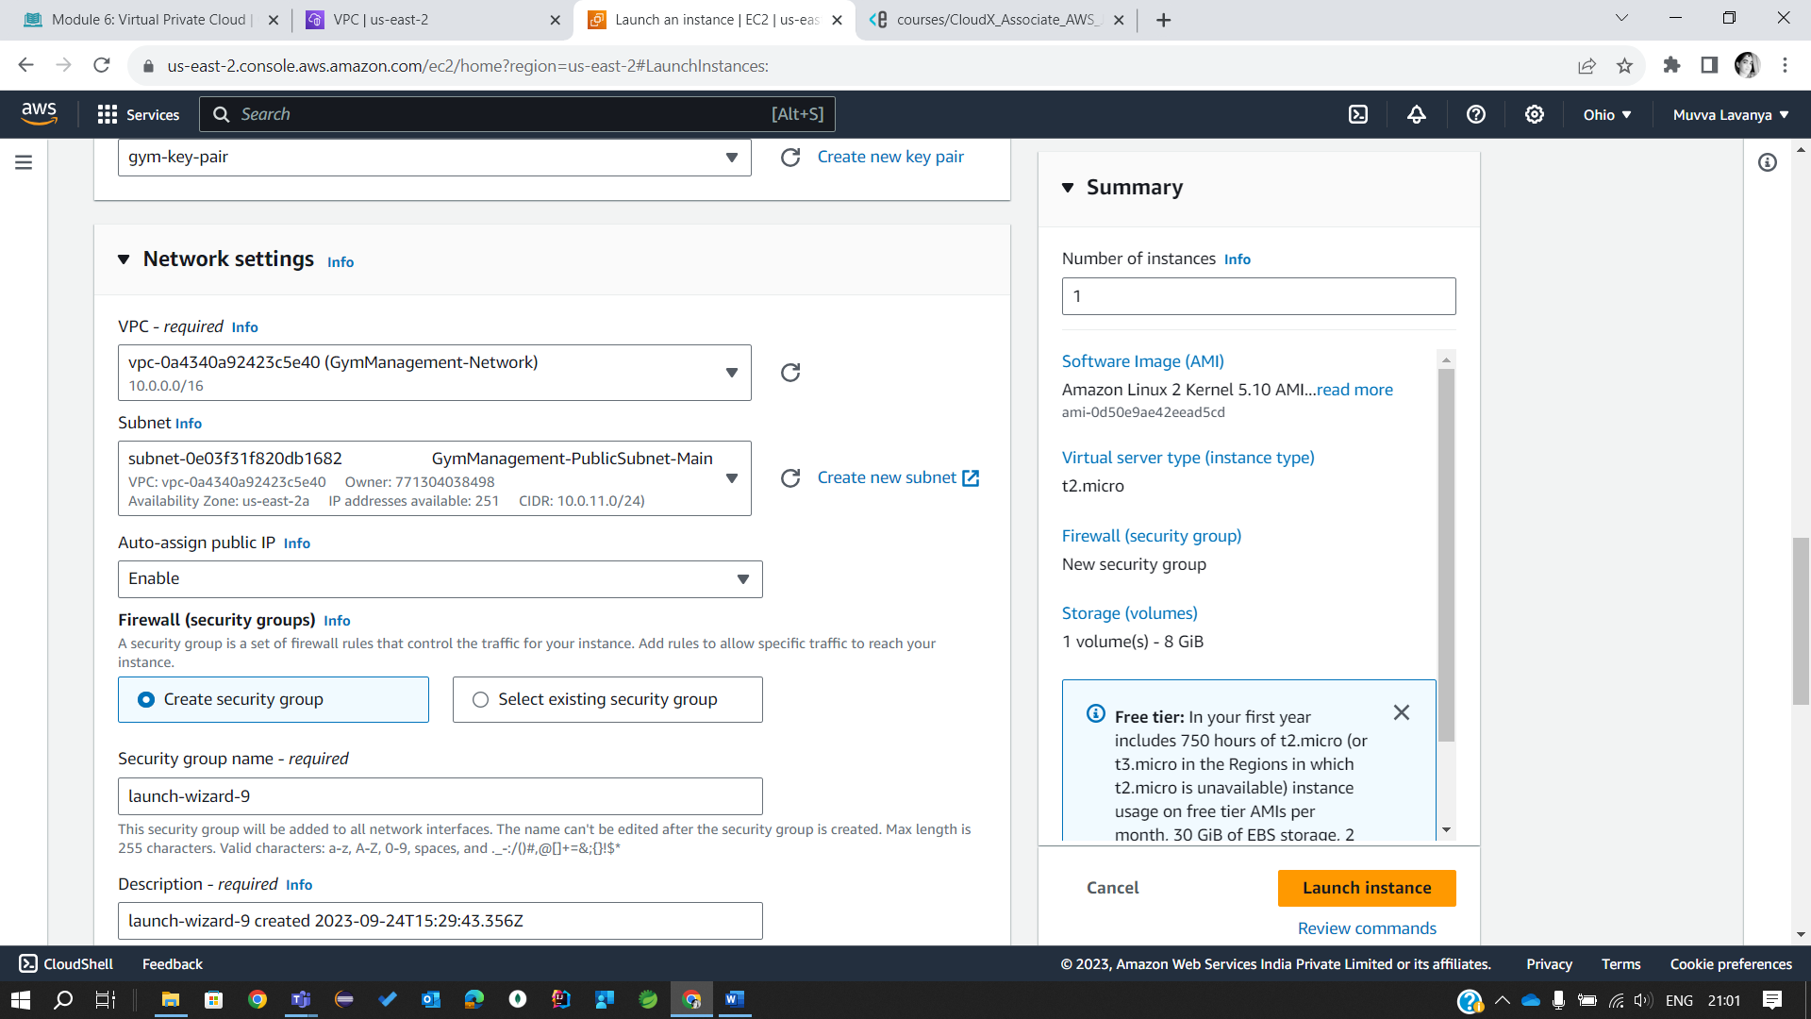

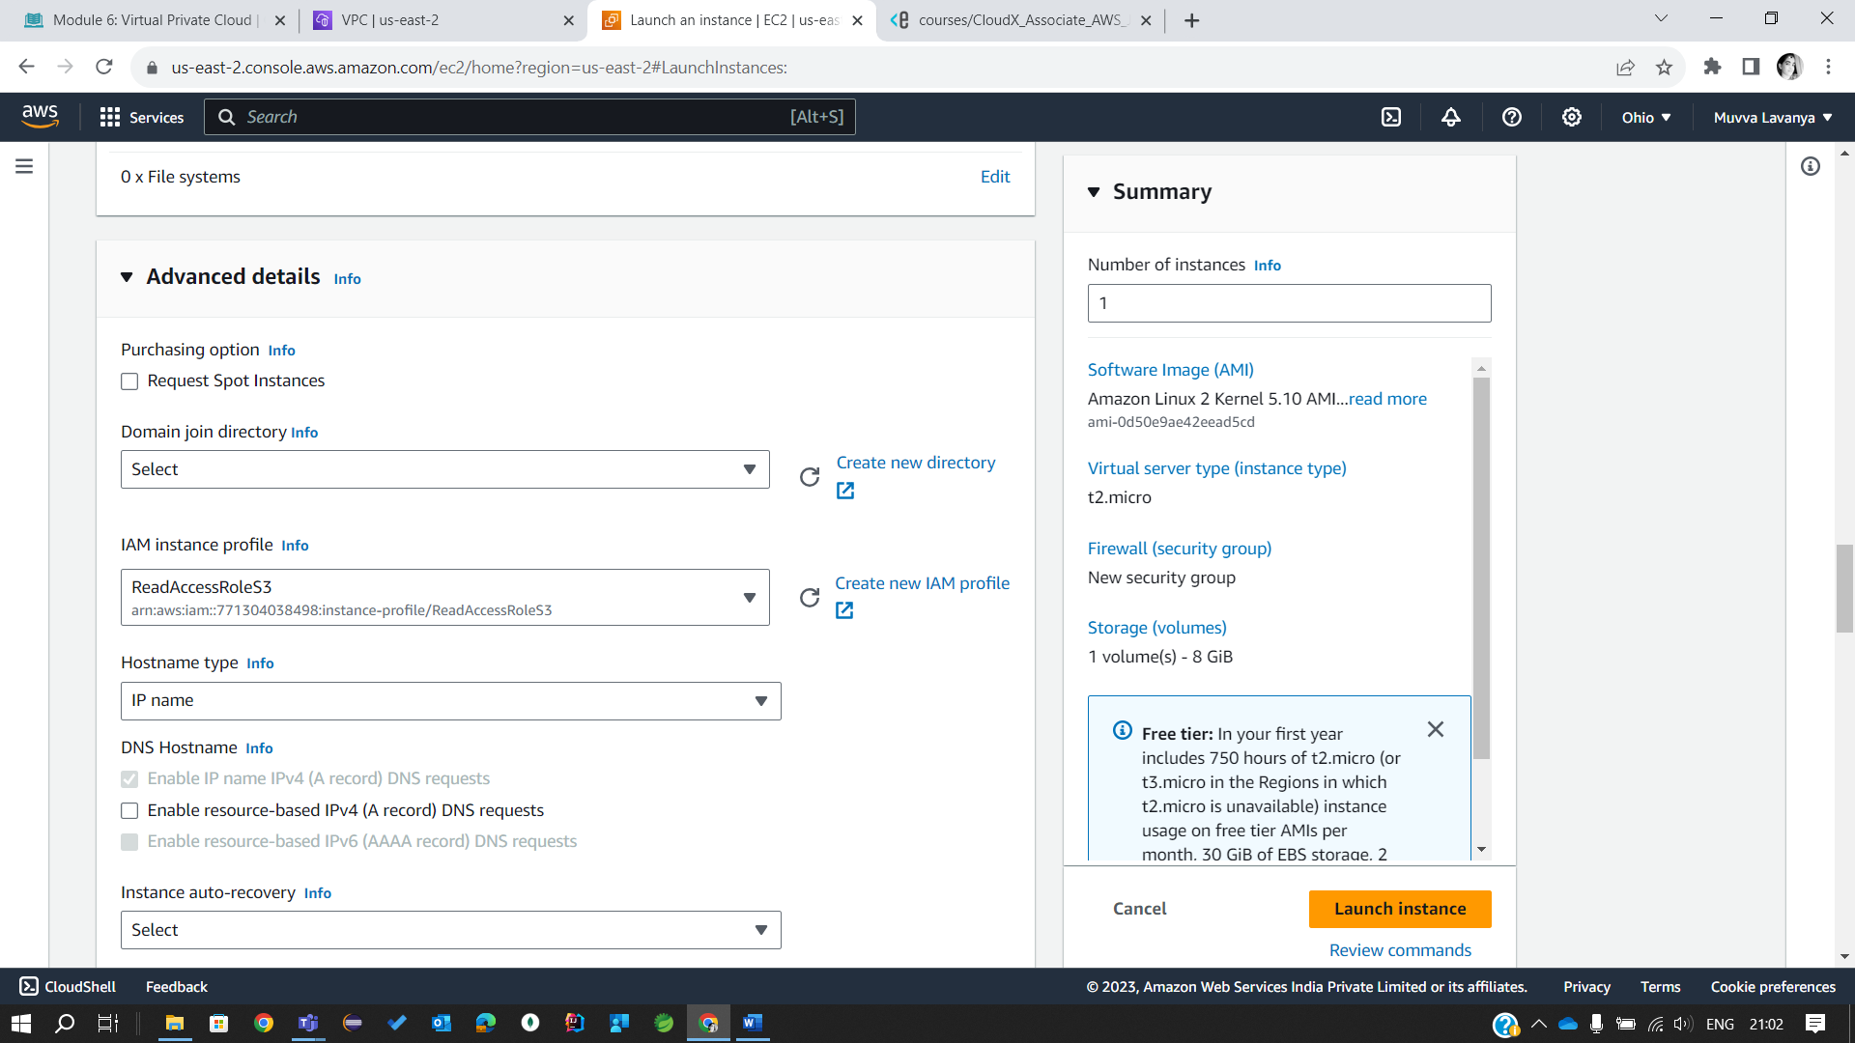

2. Create EC2 instance with the ***Report microservice*** from the previous EC2 Module in the private subnet - <ProjectName>-PrivateSubnet-Report.

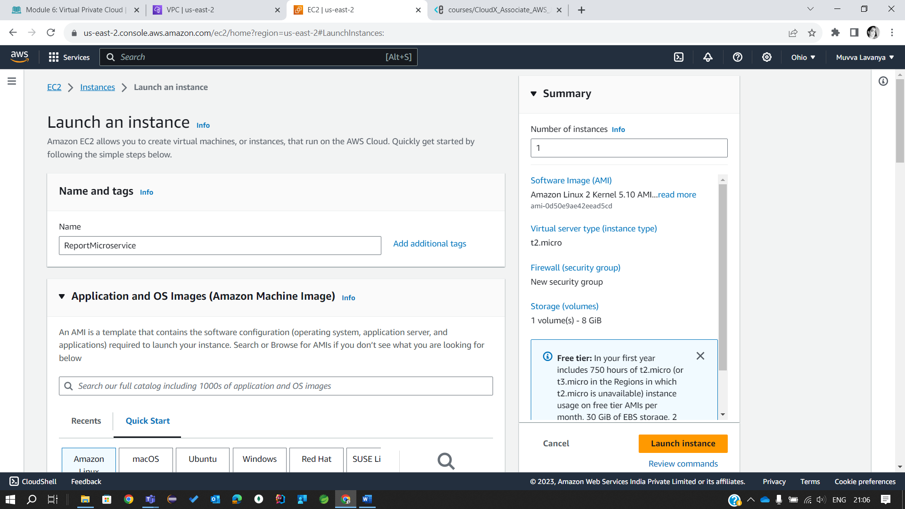

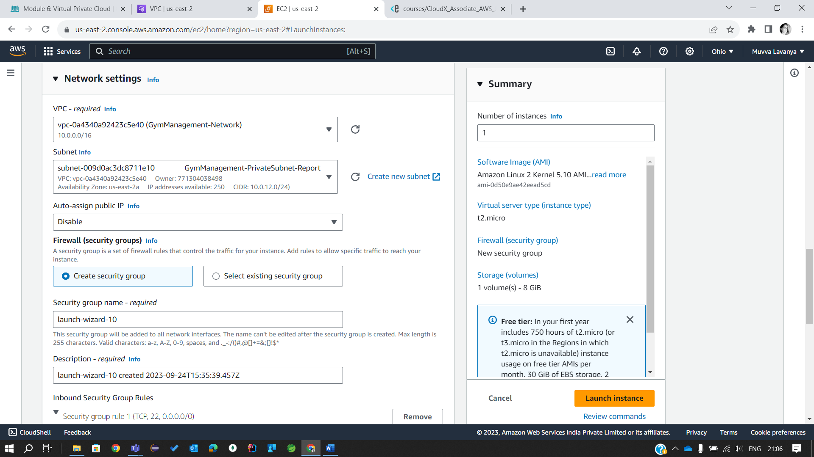

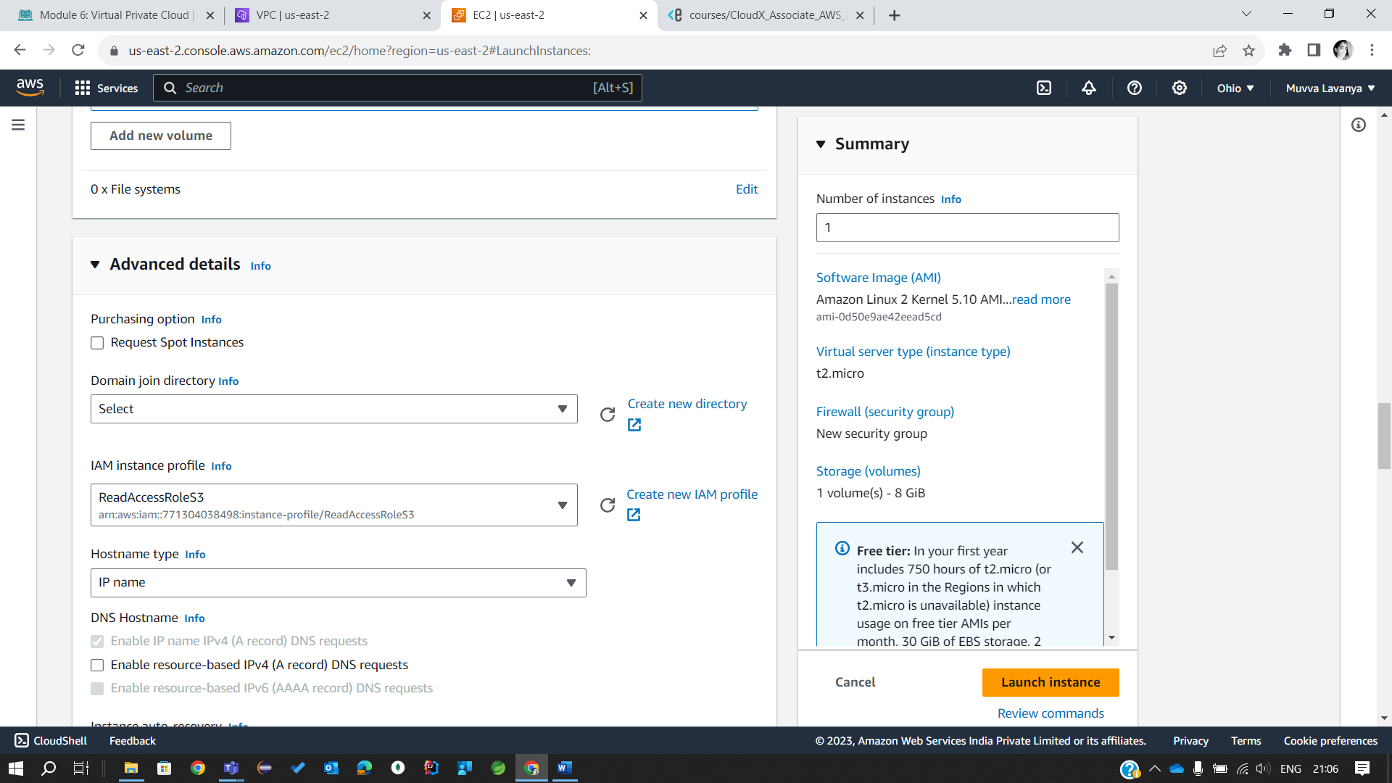

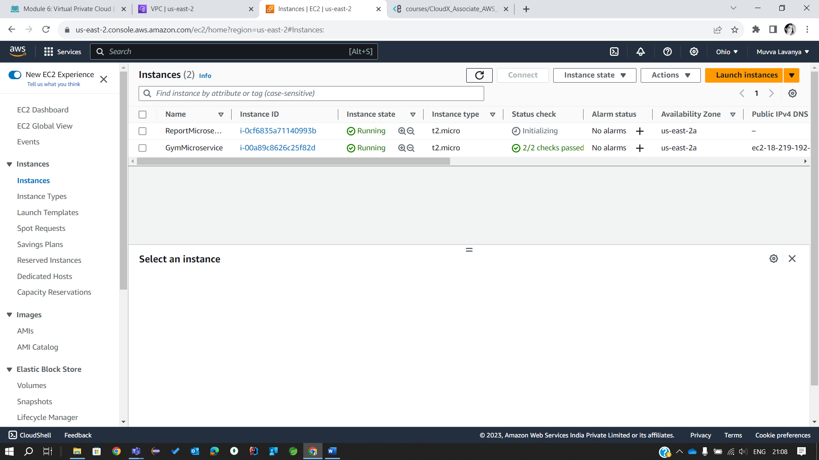

3. Create security groups:

* + To allow inbound SSH traffic only from your IP address. Apply security group to the bastion host.
  + To allow inbound HTTP/S traffic from anywhere. Apply security group to the public instance.
  + To allow all inbound traffic from other instances associated with this security group. The security group should specify itself as a source security group in its inbound rules. Apply security group to all the instances.

